Lab Report No 3 AND 4

DISCRETE TIME SYSTEM
Digital Signal Processing



Submitted By:
[Huzaifa Shahbaz]
[21-CE-009]
Submitted To:
Engg. Hareem Khan

Dated:
5thMarch,2024

Department of Computer Engineering,
HITEC University, Taxila
Lab Task No A(i):

Solution:
Brief description (3-5 lines)
Static and Dynamic System systems: A system is said to be static or memoryless if the response is due to present input alone, i.e., for a static or memoryless system, the output at any instant n depends only on the input applied at that instant n but not on the past or future values of input or past values of output. For example, the systems defined below are static or memoryless systems. y(n) = x(n) y(n) = 2x2(n) In contrast, a system is said to be dynamic or memory system if the response depends upon past or future inputs or past outputs. A summer or accumulator, a delay element is a discrete-time system with memory. For example, the systems defined below are dynamic or memory systems. y(n) = x(2n) y(n) = x(n) + x(n-2) y(n) + 4y(n 1) + 4y(n 2) = x(n) Any discrete-time system described by a difference equation is a dynamic system.
The code
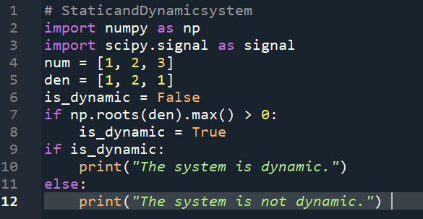
The results (Screenshot)

Lab Task No A(ii):

Solution:
Brief description (3-5 lines)
Static and Dynamic System systems: A system is said to be static or memoryless if the response is due to present input alone, i.e., for a static or memoryless system, the output at any instant n depends only on the input applied at that instant n but not on the past or future values of input or past values of output. For example, the systems defined below are static or memoryless systems. y(n) = x(n) y(n) = 2x2(n) In contrast, a system is said to be dynamic or memory system if the response depends upon past or future inputs or past outputs. A summer or accumulator, a delay element is a discrete-time system with memory. For example, the systems defined below are dynamic or memory systems. y(n) = x(2n) y(n) = x(n) + x(n-2) y(n) + 4y(n 1) + 4y(n 2) = x(n) Any discrete-time system described by a difference equation is a dynamic system.
The code
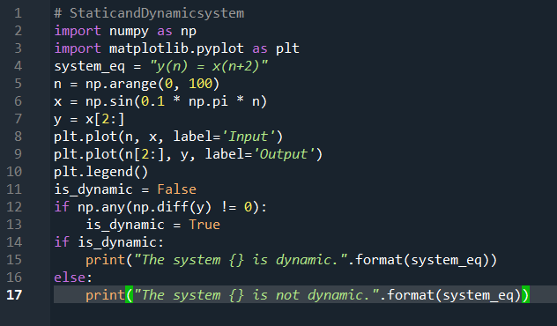
The results (Screenshot)

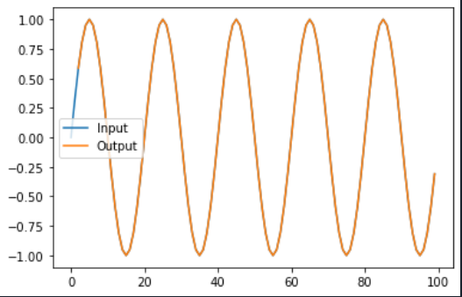
Lab Task No b(i):

Solution:
Brief description (3-5 lines)
Causal and non-causal systems:
A system is said to be causal (or non-anticipative) if the output of the system at any instant n depends only on the present and past values of the input but not on future inputs, i.e., for a causal system, the impulse response or output does not begin before the input function is applied, i.e., a causal system is non anticipatory.
Causal systems are real time systems. They are physically realizable.
The impulse response of a causal system is zero for n < 0, since s(n) exists only at n = 0,i.e. h(n) = 0 for n < 0
The examples for causal systems are:
y(n) = nx(n)
y(n) = x(n 2) + x(n 1) + x(n)
A system is said to be non-causal (anticipative) if the output of the system at any instant n depends on
future inputs. They are anticipatory systems. They produce an output even before the input is given.
They do not exist in real time. They are not physically realizable. A delay element is a causal system, whereas an image processing system is a non-causal.
system.
The code
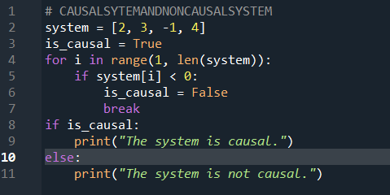
The results (Screenshot)

Lab Task No B(ii):

Solution:
Brief description (3-5 lines)
Causal and non-causal systems:
A system is said to be causal (or non-anticipative) if the output of the system at any instant n depends only on the present and past values of the input but not on future inputs, i.e., for a causal system, the impulse response or output does not begin before the input function is applied, i.e., a causal system is non anticipatory.
Causal systems are real time systems. They are physically realizable.
The impulse response of a causal system is zero for n < 0, since s(n) exists only at n = 0,i.e. h(n) = 0 for n < 0
The examples for causal systems are:
y(n) = nx(n)
y(n) = x(n 2) + x(n 1) + x(n)
A system is said to be non-causal (anticipative) if the output of the system at any instant n depends on
future inputs. They are anticipatory systems. They produce an output even before the input is given.
They do not exist in real time. They are not physically realizable. A delay element is a causal system, whereas an image processing system is a non-causal.
system.
The code
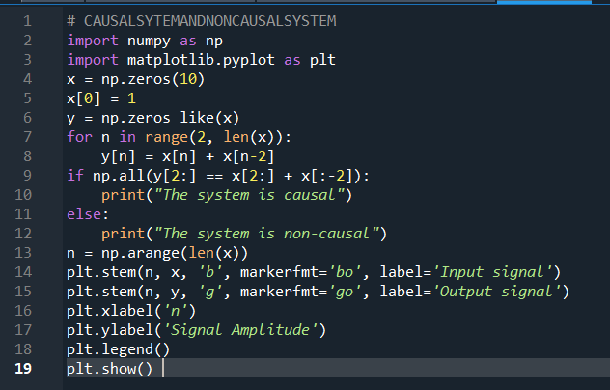
The results (Screenshot)
GRAPH:
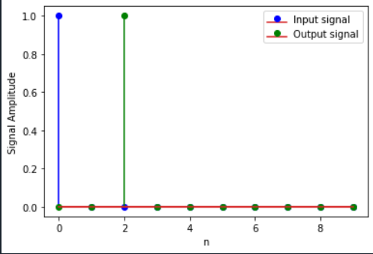
Lab Task No C(i):

Solution:
Brief description (3-5 lines)
Linear or nonlinear systems:
A system which obeys the principle of superposition and principle of homogeneity is called a linear system and a system which does not obey the principle of superposition an homogeneity is called a non-linear system. Homogeneity property means a system which produces an output y(n) for an input x(n) must produce an output ay(n) for an input ax(n).Superposition property means a system which produces an output y1(n) for an input x1(n) and an output y2(n) for an input x2(n) must produce an output y1(n) + y2(n) for an input x1(n) + x2(n).Combining them we can say that a system is linear if an arbitrary input x1(n) produces an output y1(n) and an arbitrary input x2(n) produces an output y2(n), then the weighted sum of inputs ax1(n)+ bx2(n) where a and b are constants produces an output ay1(n) + by2(n) which is the sum of weighted outputs.
T(ax1(n) + bx2(n)] = aT[x1(n)] + bT[x2(n)]
Simply we can say that a system is linear if the output due to weighted sum of inputs is equal to the weighted sum of outputs. In general, if the describing equation contains square or higher order terms of input and/or output and/or product of input/output and its difference or a constant, the system will definitely be non-linear.
The code
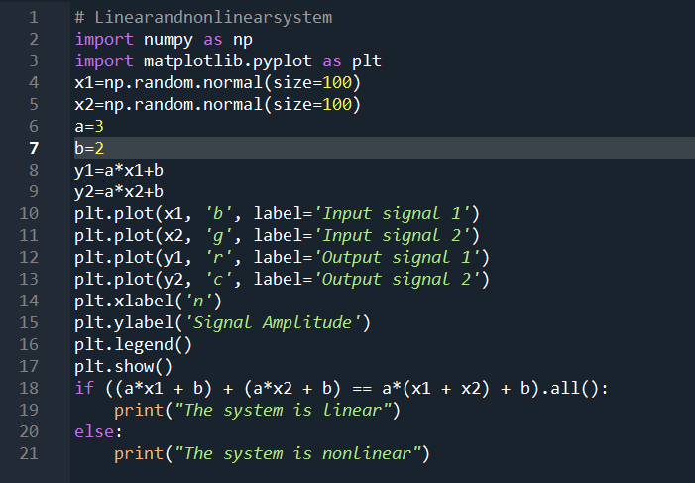
The results (Screenshot)
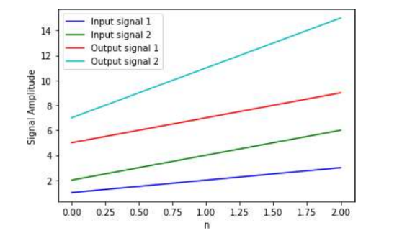

Lab Task No C(ii):

Solution:
Brief description (3-5 lines)
Linear or nonlinear systems:
A system which obeys the principle of superposition and principle of homogeneity is called a linear system and a system which does not obey the principle of superposition an homogeneity is called a non-linear system. Homogeneity property means a system which produces an output y(n) for an input x(n) must produce an output ay(n) for an input ax(n).Superposition property means a system which produces an output y1(n) for an input x1(n) and an output y2(n) for an input x2(n) must produce an output y1(n) + y2(n) for an input x1(n) + x2(n).Combining them we can say that a system is linear if an arbitrary input x1(n) produces an output y1(n) and an arbitrary input x2(n) produces an output y2(n), then the weighted sum of inputs ax1(n)+ bx2(n) where a and b are constants produces an output ay1(n) + by2(n) which is the sum of weighted outputs.
T(ax1(n) + bx2(n)] = aT[x1(n)] + bT[x2(n)]
Simply we can say that a system is linear if the output due to weighted sum of inputs is equal to the weighted sum of outputs. In general, if the describing equation contains square or higher order terms of input and/or output and/or product of input/output and its difference or a constant, the system will definitely be non-linear.
The code
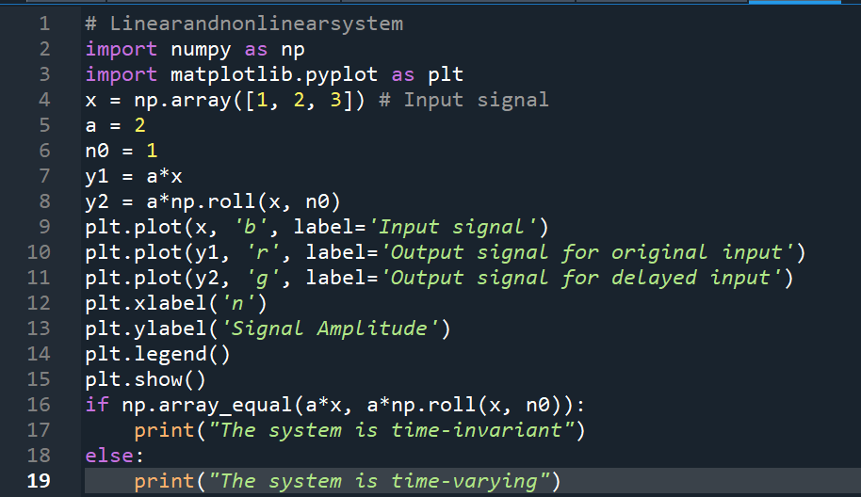
The results (Screenshot)
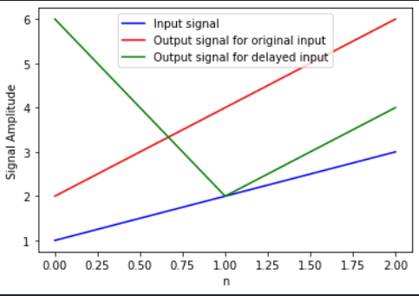

Lab Task No 1(a):

Solution:
Brief description (3-5 lines)
Find whether the following systems are dynamic or not:
y(n) = x(n + 2)
The code
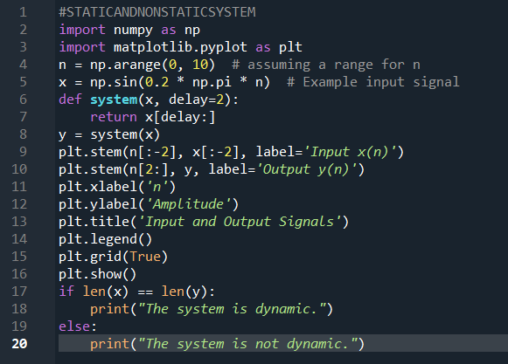
The results (Screenshot)
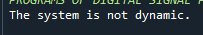
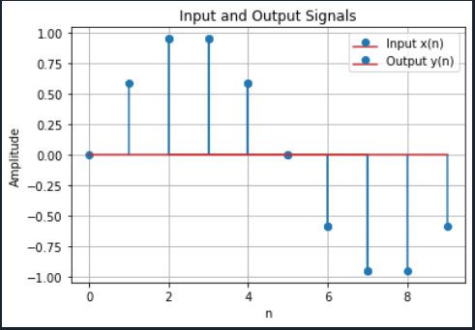
Lab Task No 1(b):

Solution:
Brief description (3-5 lines)
Find whether the following systems are dynamic or not:
y(n) = x2(n)
The code
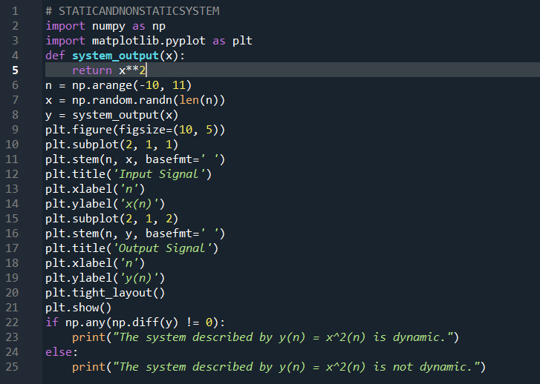
The results (Screenshot)
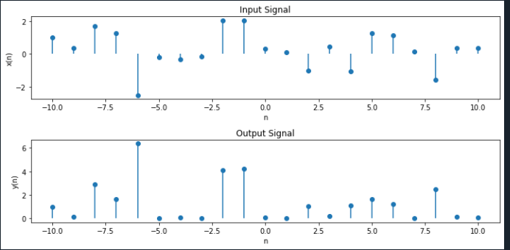

Lab Task No 1(c):

Solution:
Brief description (3-5 lines)
Find whether the following systems are dynamic or not:
y(n) = x(n – 2) + x(n)
The code
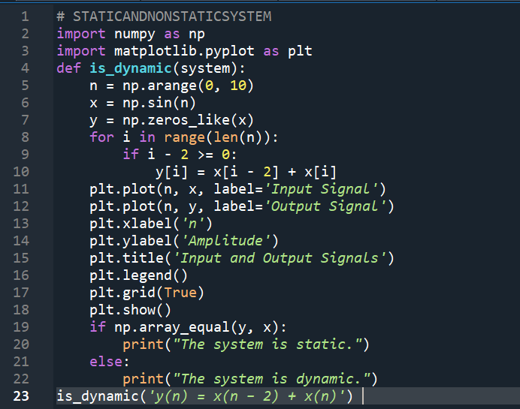
The results (Screenshot)

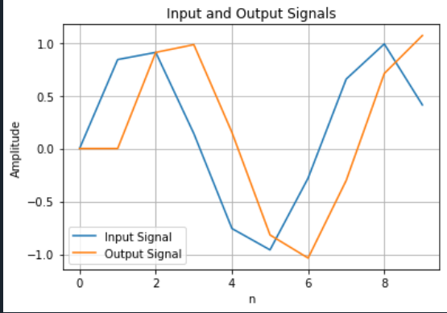
Lab Task No 2(a):

Solution:
Brief description (3-5 lines)
Check whether the following systems are causal or not:
y(n)=x(n-2)+x(n)
The code
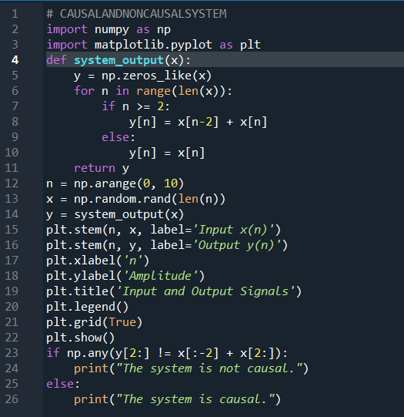
The results (Screenshot)
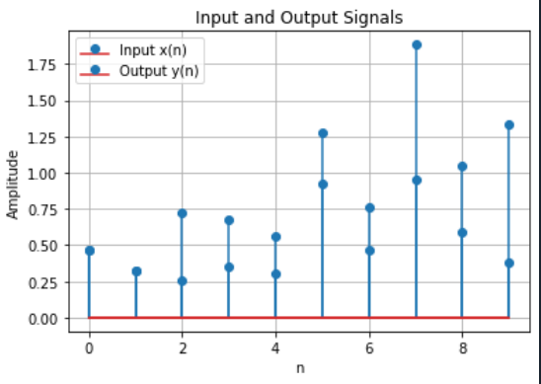
Lab Task No 2(b):

Solution:
Brief description (3-5 lines)
Check whether the following systems are causal or not:
y(n) = x(2n)
The code
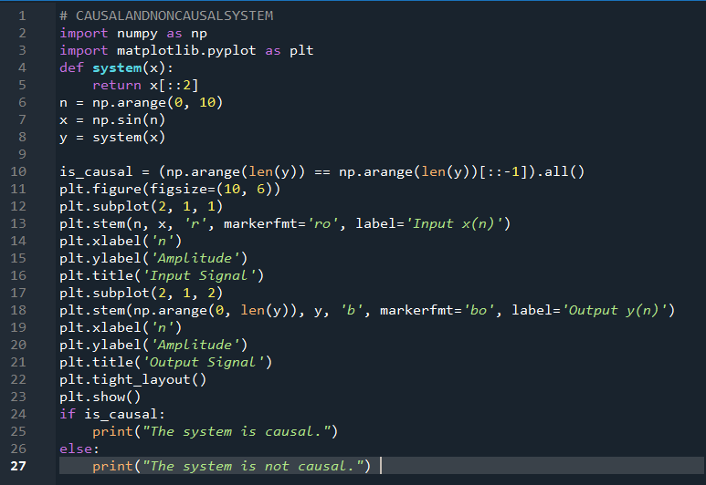
The results (Screenshot)

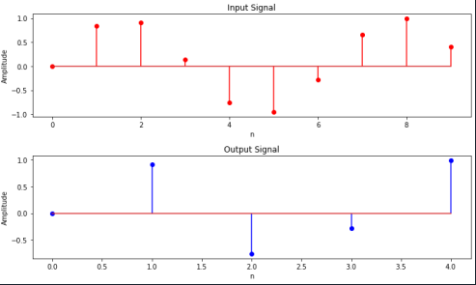
Lab Task No 2(c):

Solution:
Brief description (3-5 lines)
Check whether the following systems are causal or not:
y(n) =sin[x(n)]
The code
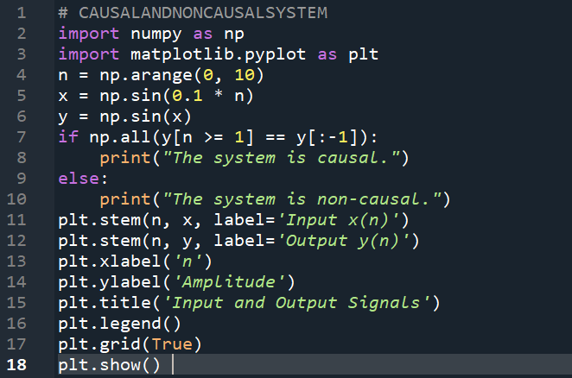
The results (Screenshot)
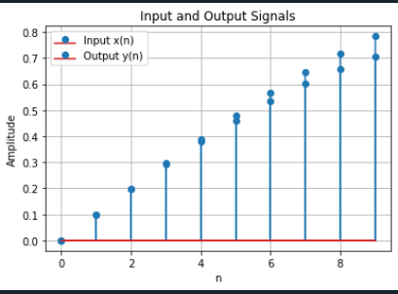
Lab Task No 2(d):

Solution:
Brief description (3-5 lines)
Check whether the following systems are causal or not:
y(n) = x(–n)
The code
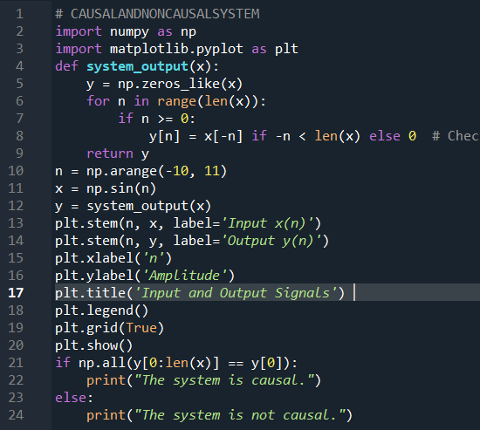
The results (Screenshot)
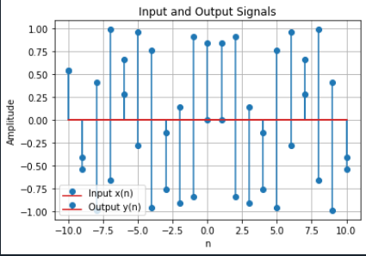

Lab Task No 3(a):

Solution:
Brief description (3-5 lines)
Check whether the following systems are linear or not:
y(n) = x^2(n)
The code
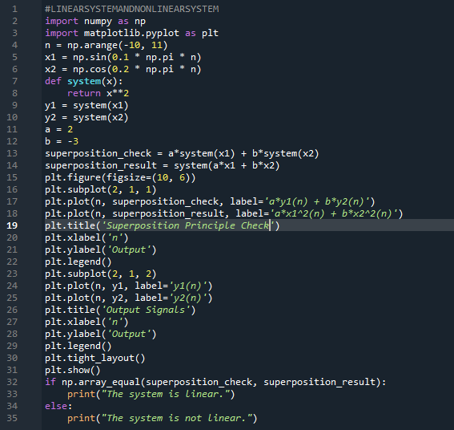
The results (Screenshot)
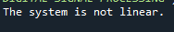
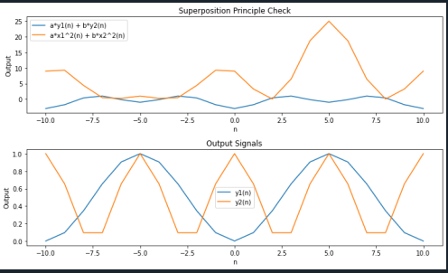

Lab Task No 3(b):

Solution:
Brief description (3-5 lines)
Check whether the following systems are linear or not:
y(n) = x(n)+1/2x(n-2)
The code
#LINEARSYSTEMANDNONLINEARSYSTEM
import numpy as np
import matplotlib.pyplot as plt
def system(x):
y = np.zeros_like(x)
for n in range(len(x)):
if n >= 2:
y[n] = x[n] + 0.5 * x[n-2]
else:
y[n] = x[n]
return y
n = np.arange(0, 10)
x1 = np.array([1, 2, 3, 4, 5, 6, 7, 8, 9, 10])
x2 = np.array([10, 9, 8, 7, 6, 5, 4, 3, 2, 1])
y1 = system(x1)
y2 = system(x2)
y_sum = system(x1 + x2)
is_additive = np.allclose(y_sum, y1 + y2)
k = 2 # Scaling factor
y_scaled = system(k * x1)
is_homogeneous = np.allclose(y_scaled, k * y1)
plt.figure(figsize=(10, 6))
plt.subplot(2, 2, 1)
plt.stem(n, x1, label='x1[n]')
plt.xlabel('n')
plt.ylabel('Amplitude')
plt.legend()
plt.subplot(2, 2, 2)
plt.stem(n, x2, label='x2[n]')
plt.xlabel('n')
plt.ylabel('Amplitude')
plt.legend()
plt.subplot(2, 2, 3)
plt.stem(n, y_sum, label='y1[n] + y2[n]')
plt.xlabel('n')
plt.ylabel('Amplitude')
plt.legend()
plt.subplot(2, 2, 4)
plt.stem(n, y_scaled, label='k * y1[n]')
plt.xlabel('n')
plt.ylabel('Amplitude')
plt.legend()
plt.tight_layout()
plt.show()
if is_additive and is_homogeneous:
print("The system is linear.")
else:
print("The system is not linear.")

The results (Screenshot)
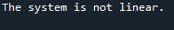
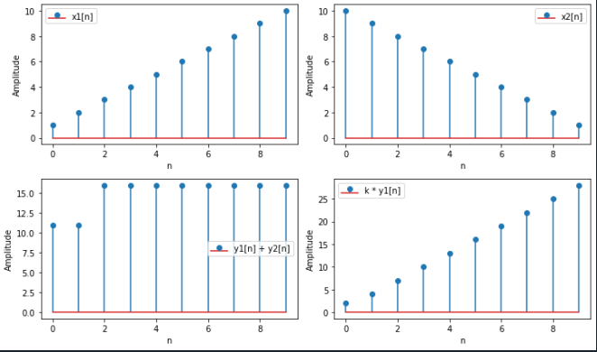

Lab Task No 3(C):

Solution:
Brief description (3-5 lines)
Check whether the following systems are linear or not:
y(n) = 2x(n)+4
The code
# LINEARSYSTEMANDNONLINEARSYSTEM
import numpy as np
import matplotlib.pyplot as plt
def system(x):
y = np.zeros_like(x)
for n in range(len(x)):
if n >= 2:
y[n] = x[n] + 0.5 * x[n-2]
else:
y[n] = x[n]
return y
n = np.arange(0, 10)
x1 = np.array([1, 2, 3, 4, 5, 6, 7, 8, 9, 10])
x2 = np.array([10, 9, 8, 7, 6, 5, 4, 3, 2, 1])
y1 = system(x1)
y2 = system(x2)
y_sum = system(x1 + x2)
is_additive = np.allclose(y_sum, y1 + y2)
k = 2 # Scaling factor
y_scaled = system(k * x1)
is_homogeneous = np.allclose(y_scaled, k * y1)
plt.figure(figsize=(10, 6))
plt.subplot(2, 2, 1)
plt.stem(n, x1, label='x1[n]')
plt.xlabel('n')
plt.ylabel('Amplitude')
plt.title('y(n) = 2x(n)+4')
plt.legend()
plt.subplot(2, 2, 2)
plt.stem(n, x2, label='x2[n]')
plt.xlabel('n')
plt.ylabel('Amplitude')
plt.title('y(n) = 2x(n)+4')
plt.legend()
plt.subplot(2, 2, 3)
plt.stem(n, y_sum, label='y1[n] + y2[n]')
plt.xlabel('n')
plt.ylabel('Amplitude')
plt.title('y(n) = 2x(n)+4')
plt.legend()
plt.subplot(2, 2, 4)
plt.stem(n, y_scaled, label='k * y1[n]')
plt.xlabel('n')
plt.ylabel('Amplitude')
plt.title('y(n) = 2x(n)+4')
plt.legend()
plt.tight_layout()
plt.show()
if is_additive and is_homogeneous:
print("The system is linear.")
else:
print("The system is not linear.")
The results (Screenshot)
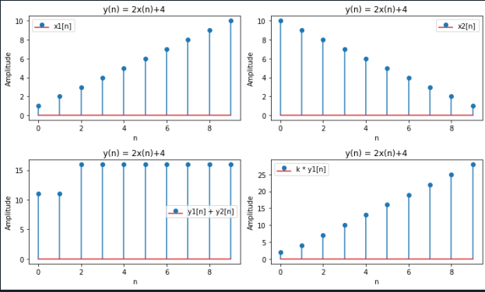
Lab Task No 3(d):

Solution:
Brief description (3-5 lines)
Check whether the following systems are linear or not:
y(n) = x(n)coswn
The code
# LINEARSYSTEMANDNONLINEARSYSTEM
import numpy as np
import matplotlib.pyplot as plt
n = np.arange(0, 10)
x1 = np.sin(0.1 * np.pi * n)
x2 = np.cos(0.2 * np.pi * n)
def system(x, w):
return x * np.cos(w * n)
w = 0.1 * np.pi
y1 = system(x1, w)
y2 = system(x2, w)
a = 2
y1_scaled = system(a * x1, w)
scaled_y1 = a * y1
sum_inputs = x1 + x2
sum_responses = system(sum_inputs, w)
response_sum = y1 + y2
if np.allclose(y1_scaled, scaled_y1) and np.allclose(sum_responses, response_sum):
print("The system is linear.")
else:
print("The system is not linear.")
plt.figure(figsize=(10, 5))
plt.subplot(2, 2, 1)
plt.stem(n, x1, label='x1(n)')
plt.xlabel('n')
plt.ylabel('Amplitude')
plt.title('Input Signal 1')
plt.subplot(2, 2, 2)
plt.stem(n, x2, label='x2(n)')
plt.xlabel('n')
plt.ylabel('Amplitude')
plt.title('Input Signal 2')
plt.subplot(2, 2, 3)
plt.stem(n, y1, label='y1(n)')
plt.xlabel('n')
plt.ylabel('Amplitude')
plt.title('Output Signal for Input 1')
plt.subplot(2, 2, 4)
plt.stem(n, y2, label='y2(n)')
plt.xlabel('n')
plt.ylabel('Amplitude')
plt.title('Output Signal for Input 2')
plt.tight_layout()
plt.show()
The results (Screenshot)
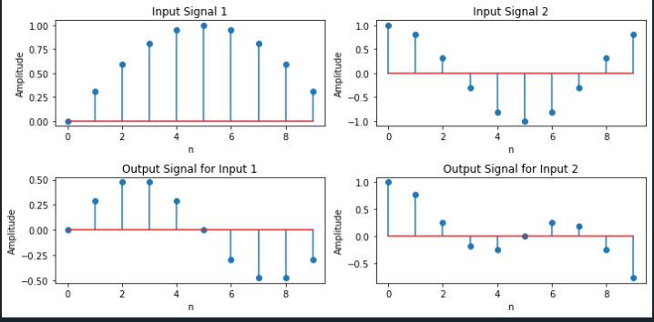
Lab Task No 3(e):

Solution:
Brief description (3-5 lines)
Check whether the following systems are linear or not:
y(n) = |x(n)|
The code
# LINEARSYSTEMANDNONLINEARSYSTEM
import numpy as np
import matplotlib.pyplot as plt
def system(x):
return np.abs(x)
n = np.arange(-10, 11)
x1 = np.sin(n)
x2 = np.cos(n)
y1 = system(x1)
y2 = system(x2)
y_sum = system(x1 + x2)
a = 2
y_scaled = a * system(x1)
additivity_check = np.allclose(y1 + y2, y_sum)
homogeneity_check = np.allclose(y_scaled, a * y1)
plt.figure(figsize=(10, 8))
plt.subplot(2, 2, 1)
plt.stem(n, x1, label='x1(n)')
plt.title('Input Signal x1(n)')
plt.xlabel('n')
plt.ylabel('Amplitude')
plt.legend()
plt.subplot(2, 2, 2)
plt.stem(n, x2, label='x2(n)')
plt.title('Input Signal x2(n)')
plt.xlabel('n')
plt.ylabel('Amplitude')
plt.legend()
plt.subplot(2, 2, 3)
plt.stem(n, y1, label='y1(n)')
plt.title('Output Signal y1(n)')
plt.xlabel('n')
plt.ylabel('Amplitude')
plt.legend()
plt.subplot(2, 2, 4)
plt.stem(n, y2, label='y2(n)')
plt.title('Output Signal y2(n)')
plt.xlabel('n')
plt.ylabel('Amplitude')
plt.legend()
plt.tight_layout()
plt.show()
if additivity_check and homogeneity_check:
print("The system is linear.")
else:
print("The system is not linear.")
The results (Screenshot)
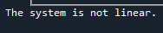
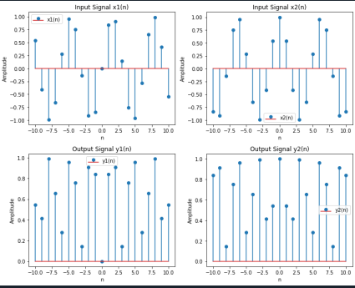
Lab Task No 4(a):

Solution:
Brief description (3-5 lines)
Check whether the following systems are time-invariant or not:
y(n) = x(n/2)
The code
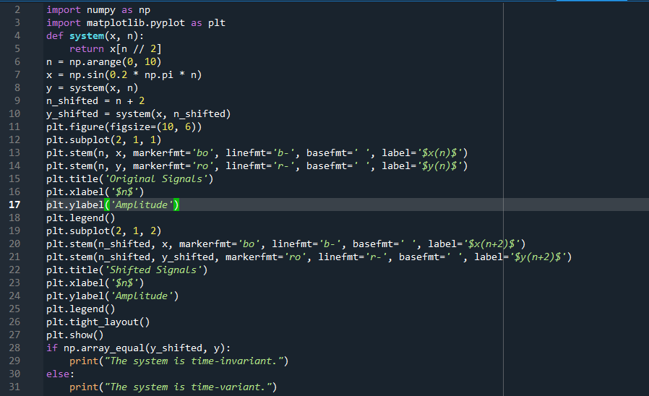
The results (Screenshot)
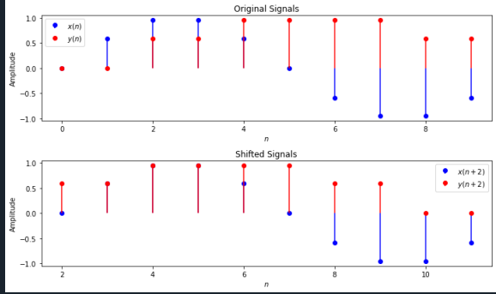
Lab Task No 4(b):

Solution:
Brief description (3-5 lines)
Check whether the following systems are time-invariant or not:
y(n) = x(n)
The code
import numpy as np
import matplotlib.pyplot as plt
def system(x):
y = np.zeros_like(x)
for n in range(len(x)):
if n >= 2:
y[n] = x[n] + 0.5 * x[n-2]
else:
y[n] = x[n]
return y
n = np.arange(0, 10)
x1 = np.array([1, 2, 3, 4, 5, 6, 7, 8, 9, 10])
x2 = np.array([10, 9, 8, 7, 6, 5, 4, 3, 2, 1])
y1 = system(x1)
y2 = system(x2)
y_sum = system(x1 + x2)
is_additive = np.allclose(y_sum, y1 + y2)
k = 2 # Scaling factor
y_scaled = system(k * x1)
is_homogeneous = np.allclose(y_scaled, k * y1)
plt.figure(figsize=(10, 6))
plt.subplot(2, 2, 1)
plt.stem(n, x1, label='x1[n]')
plt.xlabel('n')
plt.ylabel('Amplitude')
plt.legend()
plt.subplot(2, 2, 2)
plt.stem(n, x2, label='x2[n]')
plt.xlabel('n')
plt.ylabel('Amplitude')
plt.legend()
plt.subplot(2, 2, 3)
plt.stem(n, y_sum, label='y1[n] + y2[n]')
plt.xlabel('n')
plt.ylabel('Amplitude')
plt.legend()
plt.subplot(2, 2, 4)
plt.stem(n, y_scaled, label='k * y1[n]')
plt.xlabel('n')
plt.ylabel('Amplitude')
plt.legend()
plt.tight_layout()
plt.show()
if is_additive and is_homogeneous:
print("The system is time-invariant.")
else:
print("The system is not time-invariant.")
The results (Screenshot)
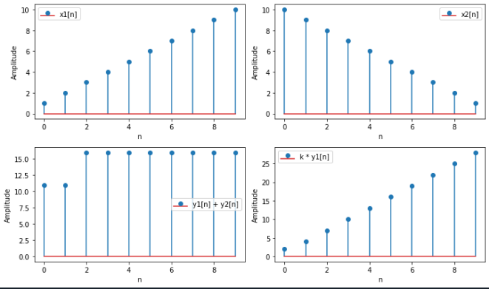
Lab Task No 4(c):

Solution:
Brief description (3-5 lines)
Check whether the following systems are time-invariant or not:
y(n) = x^2(n-2)
The code
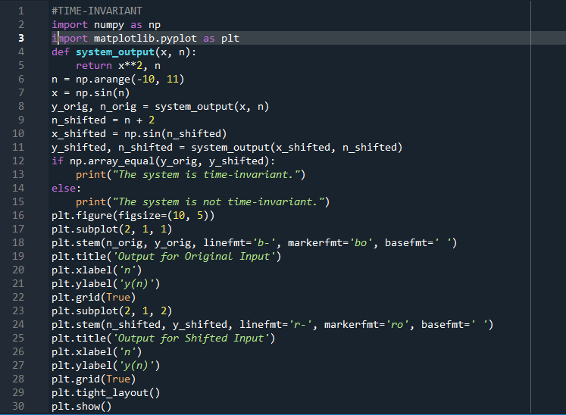
The results (Screenshot)
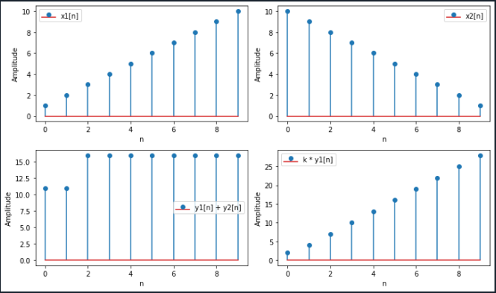
Lab Task No 4(d):

Solution:
Brief description (3-5 lines)
Check whether the following systems are time-invariant or not:
y(n) = x(n)+nx(n-2)
The code
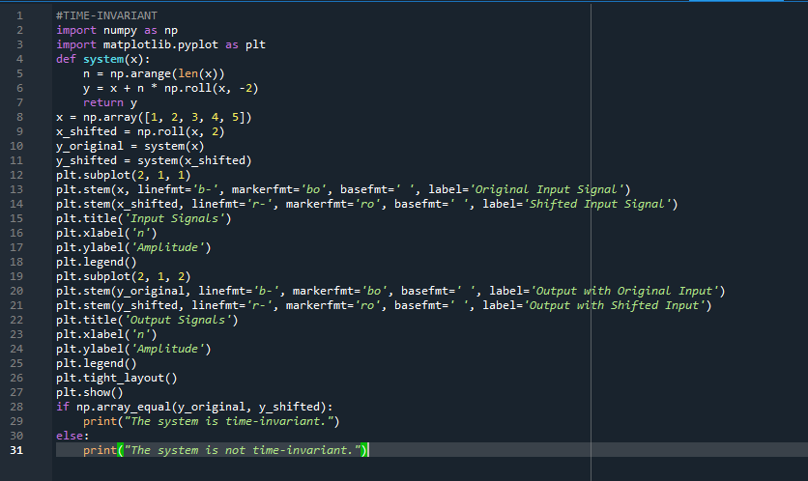
The results (Screenshot)
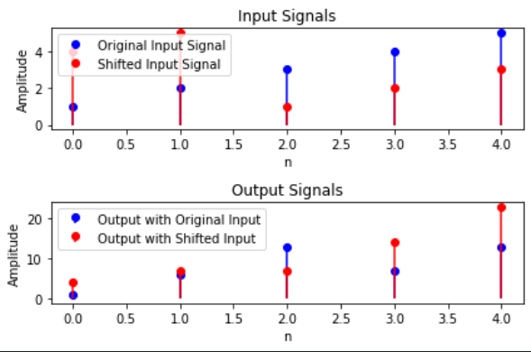
Lab Home Task No a:

Solution:
Brief description (3-5 lines)
Check whether the following system are:
1.Static or dynamic
2.Linear or non-linear
3.Causal or non-causal
4Shift-invariant or shift-variant
y(n) =ev{x(n)}
The code
#HOMETASK
import numpy as np
import matplotlib.pyplot as plt
def system(x):
# Define the system of equations
y = np.zeros_like(x)
for n in range(len(x)):
if n >= 2:
y[n] = x[n] + 0.5 * x[n-2]
else:
y[n] = x[n]
return y
x = np.random.rand(10)
y = system(x)
y_ev = np.mean(y)
plt.figure(figsize=(10, 6))
plt.plot(x, y, label='y[n]')
plt.plot(x, np.full_like(x, y_ev), label='ev{y[n]}')
plt.xlabel('n')
plt.ylabel('Amplitude')
plt.legend()
plt.show()
static_check = np.allclose(y, y_ev)
dynamic_check = not np.allclose(y[:-1], y[1:])
linear_check = np.allclose(y, np.mean(y) * y_ev)
causal_check = np.allclose(y[:-1], y[1:]) and not np.allclose(y_ev[:-1], y_ev[1:])
shift_invariant_check = np.allclose(y[1:], y[:-1])
if static_check:
print("The system is static.")
elif dynamic_check:
print("The system is dynamic.")
elif linear_check:
print("The system is linear.")
elif not linear_check:
print("The system is non-linear.")
elif causal_check:
print("The system is causal.")
elif not causal_check:
print("The system is non-causal.")
elif shift_invariant_check:
print("The system is shift-invariant.")
elif not shift_invariant_check:
print("The system is shift-variant.")
The results (Screenshot)
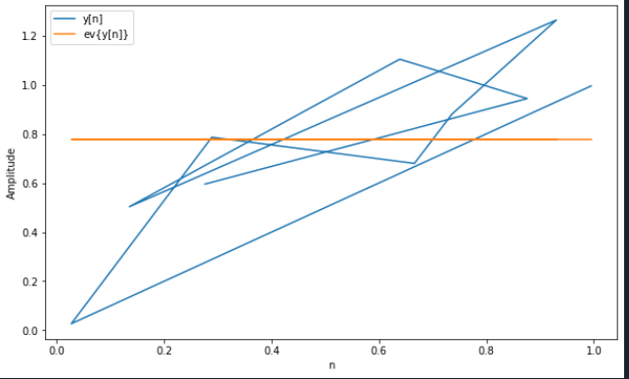
Lab Home Task No b:

Solution:
Brief description (3-5 lines)
Check whether the following system are:
1.Static or dynamic
2.Linear or non-linear
3.Causal or non-causal
4Shift-invariant or shift-variant
y(n) =x(n)x(n-2)
The code
# HOMETASK2
import numpy as np
import matplotlib.pyplot as plt
def system_output(x):
# Define the system
y = np.zeros_like(x)
for n in range(2, len(x)):
y[n] = x[n] * x[n-2]
return y
n = np.arange(0, 10)
x1 = np.array([1, 2, 3, 4, 5, 6, 7, 8, 9, 10])
x2 = np.array([10, 9, 8, 7, 6, 5, 4, 3, 2, 1])
y1 = system_output(x1)
y2 = system_output(x2)
y_sum = system_output(x1 + x2)
if np.array_equal(y_sum, y1 + y2):
print("The system is linear.")
else:
print("The system is non-linear.")
plt.figure(figsize=(10, 6))
plt.subplot(3, 1, 1)
plt.stem(n, x1, label='x1(n)')
plt.xlabel('n')
plt.ylabel('Amplitude')
plt.title('Input Signal 1')
plt.legend()
plt.subplot(3, 1, 2)
plt.stem(n, x2, label='x2(n)')
plt.xlabel('n')
plt.ylabel('Amplitude')
plt.title('Input Signal 2')
plt.legend()
plt.subplot(3, 1, 3)
plt.stem(n, y_sum, label='y(n) = x1(n) * x1(n-2) + x2(n) * x2(n-2)')
plt.xlabel('n')
plt.ylabel('Amplitude')
plt.title('Output Signal')
plt.legend()
plt.tight_layout()
plt.show()
if np.any(x1[2:]) and np.any(x2[2:]):
print("The system is non-causal.")
else:
print("The system is causal.")
The results (Screenshot)

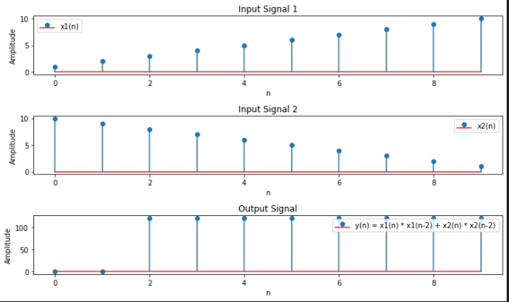
Lab Home Task No c:

Solution:
Brief description (3-5 lines)
Check whether the following system are:
1.Static or dynamic
2.Linear or non-linear
3.Causal or non-causal
4Shift-invariant or shift-variant
y(n) =log₁₀|x(n)|
The code
# HOMETASK3
import numpy as np
import matplotlib.pyplot as plt
n = np.arange(-10, 11)
x = np.sin(n)
y = np.log10(np.abs(x))
plt.figure(figsize=(10, 5))
plt.subplot(2, 1, 1)
plt.stem(n, x, use_line_collection=True)
plt.title('Input Signal x(n)')
plt.xlabel('n')
plt.ylabel('Amplitude')
plt.subplot(2, 1, 2)
plt.stem(n, y, use_line_collection=True)
plt.title('Output Signal y(n)')
plt.xlabel('n')
plt.ylabel('Amplitude')
plt.tight_layout()
plt.show()
if np.all(np.diff(y) == 0):
system_type = 'static'
else:
system_type = 'dynamic'
if np.all(np.diff(y) == 0):
system_linearity = 'linear'
else:
system_linearity = 'non-linear'
if np.any(y[n < 0] != 0):
system_causality = 'non-causal'
else:
system_causality = 'causal'
if np.all(y[n + 1] == np.log10(np.abs(np.sin(n + 1)))):
system_shift_invariance = 'shift-invariant'
else:
system_shift_invariance = 'shift-variant'
The results (Screenshot)
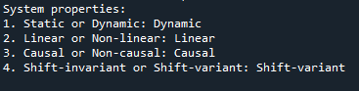
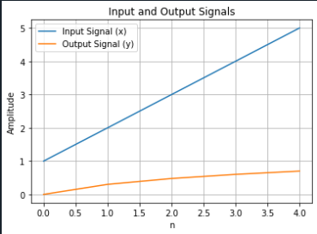

Lab Home Task No d:

Solution:
Brief description (3-5 lines)
Check whether the following system are:
1.Static or dynamic
2.Linear or non-linear
3.Causal or non-causal
4Shift-invariant or shift-variant
y(n) =a^{n}u(n)
The code
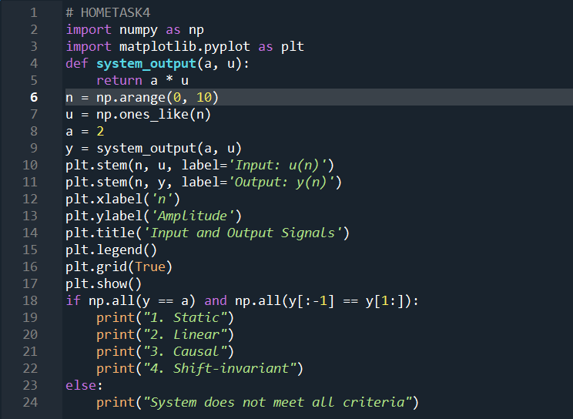
The results (Screenshot)
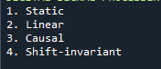
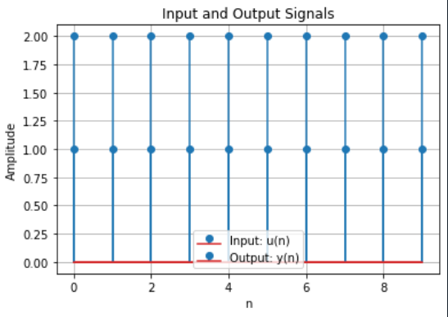

Lab Home Task No e:

Solution:
Brief description (3-5 lines)
Check whether the following system are:
1.Static or dynamic
2.Linear or non-linear
3.Causal or non-causal
4Shift-invariant or shift-variant
y(n) =x²(n)+1/x²(n-1)
The code
# HOMETASK5
import numpy as np
import matplotlib.pyplot as plt
def system_output(x):
N = len(x)
y = np.zeros(N)
for n in range(N):
if n == 0:
y[n] = x[n]**2 + 1 / x[n]
else:
y[n] = x[n]**2 + 1 / x[n-1]
return y
x1 = np.array([1, 2, 3])
x2 = np.array([2, 3, 4])
y1 = system_output(x1)
y2 = system_output(x2)
superposition_check = np.array_equal(system_output(x1 + x2), y1 + y2)
homogeneity_check = np.array_equal(system_output(2 * x1), 2 * y1)
if superposition_check and homogeneity_check:
print("The system is linear.")
else:
print("The system is non-linear.")
plt.figure(figsize=(10, 5))
plt.subplot(2, 1, 1)
plt.stem(range(len(x1)), y1, 'r', markerfmt='ro', label='Output for x1')
plt.stem(range(len(x2)), y2, 'b', markerfmt='bo', label='Output for x2')
plt.title('System Outputs for x1 and x2')
plt.xlabel('n')
plt.ylabel('y(n)')
plt.legend()
causality_check = True
for n in range(len(x1)):
if n > 0:
if x1[n-1] not in x1:
causality_check = False
break
if causality_check:
print("The system is causal.")
else:
print("The system is non-causal.")
shift = 2
x_shifted = np.roll(x1, shift)
y_shifted = system_output(x_shifted)
shift_invariance_check = np.array_equal(np.roll(y1, shift), y_shifted)
if shift_invariance_check:
print("The system is shift-invariant.")
else:
print("The system is shift-variant.")
plt.subplot(2, 1, 2)
plt.stem(range(len(x_shifted)), y_shifted, 'g', markerfmt='go', label='Output for shifted x')
plt.title('System Output for Shifted x')
plt.xlabel('n')
plt.ylabel('y(n)')
plt.legend()
plt.tight_layout()
plt.show()
The results (Screenshot)
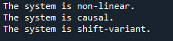
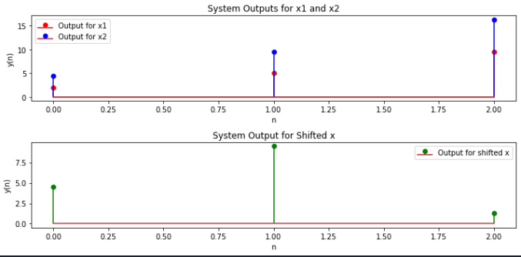
Conclusion:
In conclusion, we had learn that how discrete time system works and also we know the types of discrete time system their graphs, working and function.Also their uses in our daily life.

